

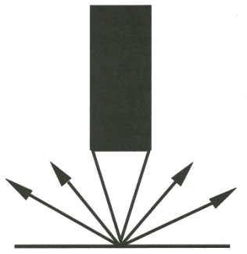
Advanced
Engraving
3050 Washington St. Columbus, Indiana 47201
812-371-5191 www.advancedengraving.net

We will be available at
Age Group State Meet
To engrave the Medals!
Bring your medals from this meet and other meets!
$7.00 per medal
Service is done quickly while you wait!

